- Install Packages called ncompress,ksh.
- Compress a file by gzip, bzip2 commands and decompress it again.
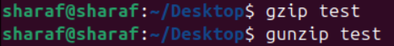
- List the directories that have 777 Permissions in the system.
- Remove package ncompress and ksh.
- Install Vlc , Vscode ,Atom ,Krita, Google Chrome ,Libre office, zoom and teams.
- Wget (web get)
  - It’s a command-line tool used to download files from the internet.
- gpg stands for GNU Privacy Guard.
It’s a tool for encryption, decryption, and signing data and files — part of the OpenPGP standard (Pretty Good Privacy).

